**20 july**

**1)Add 2) drop queries**

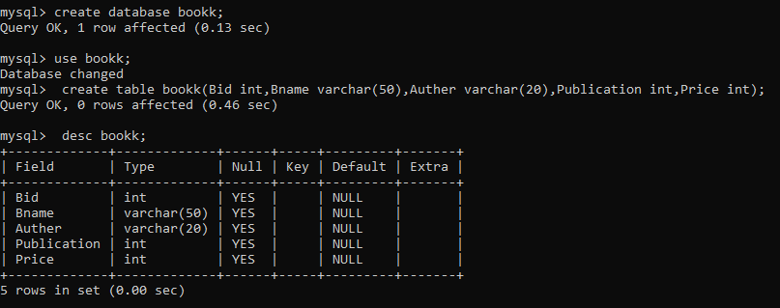

**Q1) Modify column**

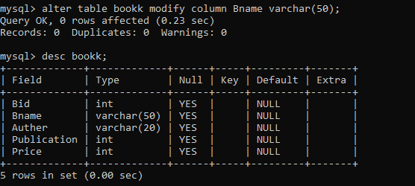

**Q2)Modify column**

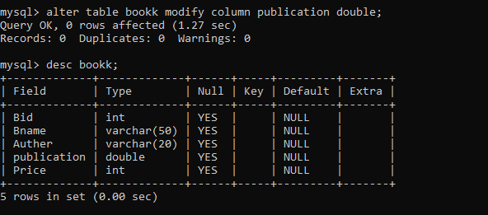

**Q1)Add column**

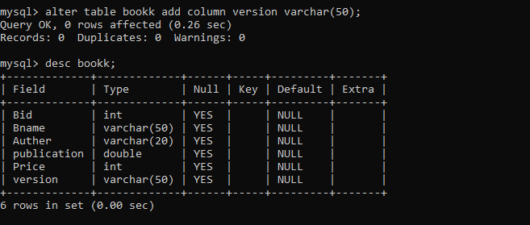

**Q2)Add column**

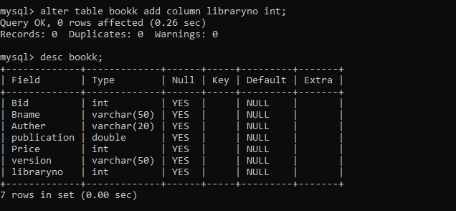

**Q3)Add column**

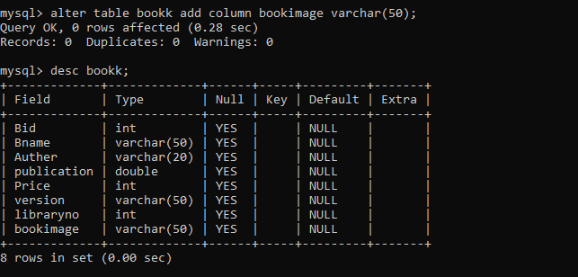

**Q4)Drop column**

1)price

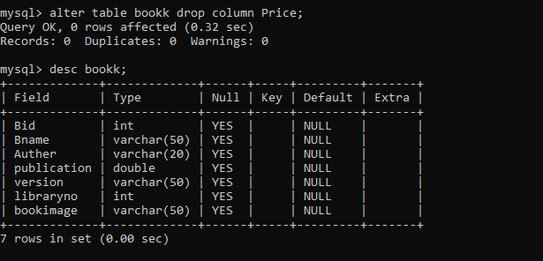

2) column libraryno

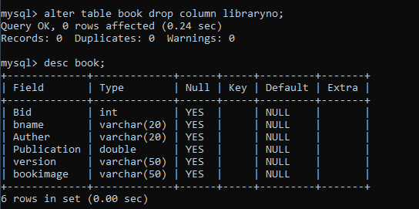

**Rename Table:-**

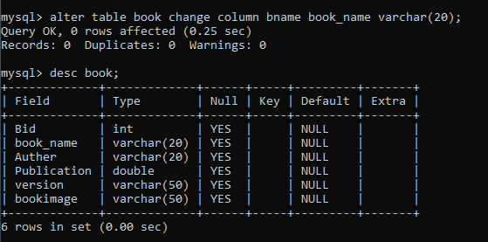

**1)Rename column**

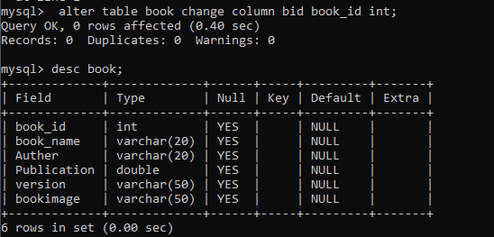

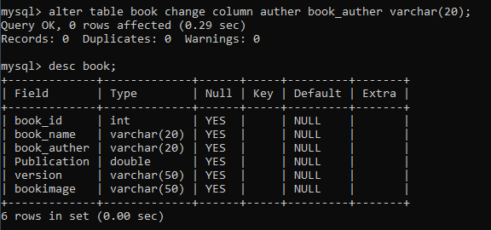

**SQL NOT NULL CONSRAINT**

mysql> create table patient(id int not null,lastname varchar(255) not null,fristname varchar(255) not null,age int);

Query OK, 0 rows affected (0.06 sec)

mysql> desc patient;

+-----------+--------------+------+-----+---------+-------+

| Field | Type | Null | Key | Default | Extra |

+-----------+--------------+------+-----+---------+-------+

| id | int | NO | | NULL | |

| lastname | varchar(255) | NO | | NULL | |

| fristname | varchar(255) | NO | | NULL | |

| age | int | YES | | NULL | |

+-----------+--------------+------+-----+---------+-------+

4 rows in set (0.01 sec)

**Q 2. NULL column-**

mysql> create table person(id int not null,lastname varchar(255) not null,fristname varchar(255) not null,age int);

Query OK, 0 rows affected (0.03 sec)

mysql> desc person;

+-----------+--------------+------+-----+---------+-------+

| Field | Type | Null | Key | Default | Extra |

+-----------+--------------+------+-----+---------+-------+

| id | int | NO | | NULL | |

| lastname | varchar(255) | NO | | NULL | |

| fristname | varchar(255) | NO | | NULL | |

| age | int | YES | | NULL | |

+-----------+--------------+------+-----+---------+-------+

4 rows in set (0.00 sec)

**Q 2. NULL column-**

mysql> create table patient(id int ,lastname varchar(255) not null,fristname varchar(255) not null,age int);

ERROR 1050 (42S01): Table 'patient' already exists

mysql> create table candidate(id int,lastname varchar(255) not null,fristname varchar(255) not null,age int);

Query OK, 0 rows affected (0.04 sec)

mysql> desc candidate;

+-----------+--------------+------+-----+---------+-------+

| Field | Type | Null | Key | Default | Extra |

+-----------+--------------+------+-----+---------+-------+

| id | int | YES | | NULL | |

| lastname | varchar(255) | NO | | NULL | |

| fristname | varchar(255) | NO | | NULL | |

| age | int | YES | | NULL | |

+-----------+--------------+------+-----+---------+-------+

4 rows in set (0.00 sec)

**SQL UNIQUE CONSTAINT ON CREATE TABLE**

mysql> create table persons(id int not null unique,lastname varchar(255) not null,fristname varchar(255),age int);

Query OK, 0 rows affected (0.04 sec)

mysql> desc persons;

+-----------+--------------+------+-----+---------+-------+

| Field | Type | Null | Key | Default | Extra |

+-----------+--------------+------+-----+---------+-------+

| id | int | NO | PRI | NULL | |

| lastname | varchar(255) | NO | | NULL | |

| fristname | varchar(255) | YES | | NULL | |

| age | int | YES | | NULL | |

+-----------+--------------+------+-----+---------+-------+

4 rows in set (0.00 sec)

**Q 1,MySQL**

create table p(id int not null unique,lastname varchar(255),fristname varchar(255),age int,unique(id));

Query OK, 0 rows affected, 1 warning (0.17 sec)

mysql> desc p;

+-----------+--------------+------+-----+---------+-------+

| Field | Type | Null | Key | Default | Extra |

+-----------+--------------+------+-----+---------+-------+

| id | int | NO | PRI | NULL | |

| lastname | varchar(255) | YES | | NULL | |

| fristname | varchar(255) | YES | | NULL | |

| age | int | YES | | NULL | |

+-----------+--------------+------+-----+---------+-------+

4 rows in set (0.01 sec)

**SQL UNIQUE CONSTAINT ON ALTER TABLE**

mysql> use person;

Database changed

mysql> create table person(id int,firstname varchar(20),lastname varchar(20));

Query OK, 0 rows affected (0.35 sec)

mysql> desc person;

+-----------+-------------+------+-----+---------+-------+

| Field | Type | Null | Key | Default | Extra |

+-----------+-------------+------+-----+---------+-------+

| id | int | YES | | NULL | |

| firstname | varchar(20) | YES | | NULL | |

| lastname | varchar(20) | YES | | NULL | |

+-----------+-------------+------+-----+---------+-------+

3 rows in set (0.00 sec)

**ADD CONSTRAINT-**

mysql> alter table person add constraint oit unique (id,lastname);

Query OK, 0 rows affected (0.54 sec)

Records: 0 Duplicates: 0 Warnings: 0

mysql> desc person;

+-----------+-------------+------+-----+---------+-------+

| Field | Type | Null | Key | Default | Extra |

+-----------+-------------+------+-----+---------+-------+

| id | int | YES | MUL | NULL | |

| firstname | varchar(20) | YES | | NULL | |

| lastname | varchar(20) | YES | | NULL | |

+-----------+-------------+------+-----+---------+-------+

3 rows in set (0.00 sec)

**DROP CONSTAINT**

mysql> alter table person drop constraint oit;

Query OK, 0 rows affected (0.23 sec)

Records: 0 Duplicates: 0 Warnings: 0

mysql> desc person;

+-----------+-------------+------+-----+---------+-------+

| Field | Type | Null | Key | Default | Extra |

+-----------+-------------+------+-----+---------+-------+

| id | int | YES | | NULL | |

| firstname | varchar(20) | YES | | NULL | |

| lastname | varchar(20) | YES | | NULL | |

+-----------+-------------+------+-----+---------+-------+

3 rows in set (0.00 sec)

**ADD CONSTRAINT-**

mysql> alter table person add constraint oit unique(id,lastname);

Query OK, 0 rows affected (0.20 sec)

Records: 0 Duplicates: 0 Warnings: 0

mysql> desc person;

+-----------+-------------+------+-----+---------+-------+

| Field | Type | Null | Key | Default | Extra |

+-----------+-------------+------+-----+---------+-------+

| id | int | YES | MUL | NULL | |

| firstname | varchar(20) | YES | | NULL | |

| lastname | varchar(20) | YES | | NULL | |

+-----------+-------------+------+-----+---------+-------+

3 rows in set (0.00 sec)

**ADD CONSTRAINT-**

mysql> alter table person drop constraint oit;

Query OK, 0 rows affected (0.23 sec)

Records: 0 Duplicates: 0 Warnings: 0

mysql> desc person;

+-----------+-------------+------+-----+---------+-------+

| Field | Type | Null | Key | Default | Extra |

+-----------+-------------+------+-----+---------+-------+

| id | int | YES | | NULL | |

| firstname | varchar(20) | YES | | NULL | |

| lastname | varchar(20) | YES | | NULL | |

+-----------+-------------+------+-----+---------+-------+

3 rows in set (0.00 sec)

**DROP CONSTAINT**

mysql> alter table person drop constraint oit;

Query OK, 0 rows affected (0.23 sec)

Records: 0 Duplicates: 0 Warnings: 0

mysql> desc person;

+-----------+-------------+------+-----+---------+-------+

| Field | Type | Null | Key | Default | Extra |

+-----------+-------------+------+-----+---------+-------+

| id | int | YES | | NULL | |

| firstname | varchar(20) | YES | | NULL | |

| lastname | varchar(20) | YES | | NULL | |

+-----------+-------------+------+-----+---------+-------+

3 rows in set (0.00 sec)

mysql> create database per;

Query OK, 1 row affected (0.12 sec)

mysql> use per;

Database changed

mysql> create table per(id int not null,lastname varchar(255)not null,fristname varchar(255),age int,constraint oit unique(id,lastname));

Query OK, 0 rows affected (0.44 sec)

mysql> desc per;

+-----------+--------------+------+-----+---------+-------+

| Field | Type | Null | Key | Default | Extra |

+-----------+--------------+------+-----+---------+-------+

| id | int | NO | PRI | NULL | |

| lastname | varchar(255) | NO | PRI | NULL | |

| fristname | varchar(255) | YES | | NULL | |

| age | int | YES | | NULL | |

+-----------+--------------+------+-----+---------+-------+

4 rows in set (0.00 sec)

mysql> insert into per values(101,'abc','xyz',23),(102,'abc','xyz',23);

Query OK, 2 rows affected (0.19 sec)

Records: 2 Duplicates: 0 Warnings: 0

mysql> select *from per;

+-----+----------+-----------+------+

| id | lastname | fristname | age |

+-----+----------+-----------+------+

| 101 | abc | xyz | 23 |

| 102 | abc | xyz | 23 |

+-----+----------+-----------+------+

2 rows in set (0.00 sec)

mysql> alter table per drop constraint oit;

Query OK, 2 rows affected (1.75 sec)

Records: 2 Duplicates: 0 Warnings: 0

mysql> select * from per;

+-----+----------+-----------+------+

| id | lastname | fristname | age |

+-----+----------+-----------+------+

| 101 | abc | xyz | 23 |

| 102 | abc | xyz | 23 |

+-----+----------+-----------+------+

2 rows in set (0.00 sec)

mysql> select* from oit;

+------+-----------+----------+

| id | fristname | lastname |

+------+-----------+----------+

| 101 | komal | bagal |

+------+-----------+----------+

1 row in set (0.00 sec)

mysql> create table per1(id int not null,lastname varchar(255) not null,fristname varchar(255),age int check(age>=18));

Query OK, 0 rows affected (0.04 sec)

mysql> desc per1;

+-----------+--------------+------+-----+---------+-------+

| Field | Type | Null | Key | Default | Extra |

+-----------+--------------+------+-----+---------+-------+

| id | int | NO | | NULL | |

| lastname | varchar(255) | NO | | NULL | |

| fristname | varchar(255) | YES | | NULL | |

| age | int | YES | | NULL | |

+-----------+--------------+------+-----+---------+-------+

4 rows in set (0.00 sec)

mysql> use employe1;

Database changed

mysql> create table empoye1(id int not null,lastname varchar(255) not null,fristname varchar(255),age int check(age>=18));

Query OK, 0 rows affected (0.41 sec)

mysql> desc empoye1;

+-----------+--------------+------+-----+---------+-------+

| Field | Type | Null | Key | Default | Extra |

+-----------+--------------+------+-----+---------+-------+

| id | int | NO | | NULL | |

| lastname | varchar(255) | NO | | NULL | |

| fristname | varchar(255) | YES | | NULL | |

| age | int | YES | | NULL | |

+-----------+--------------+------+-----+---------+-------+

**SQL PRIMARY KEY ON CONSTAINT**

**CREATE TABLE**

mysql> desc per;

+-----------+--------------+------+-----+---------+-------+

| Field | Type | Null | Key | Default | Extra |

+-----------+--------------+------+-----+---------+-------+

| id | int | NO | | NULL | |

| lastname | varchar(255) | NO | | NULL | |

| fristname | varchar(255) | YES | | NULL | |

| age | int | YES | | NULL | |

+-----------+--------------+------+-----+---------+-------+

4 rows in set (0.00 sec)

mysql> select * from per;

+-----+----------+-----------+------+

| id | lastname | fristname | age |

+-----+----------+-----------+------+

| 101 | abc | xyz | 23 |

| 102 | abc | xyz | 23 |

+-----+----------+-----------+------+

2 rows in set (0.00 sec)

mysql> alter table per add constraint check(age>=1 and age<=125);

Query OK, 2 rows affected (1.34 sec)

Records: 2 Duplicates: 0 Warnings: 0

mysql> desc per;

+-----------+--------------+------+-----+---------+-------+

| Field | Type | Null | Key | Default | Extra |

+-----------+--------------+------+-----+---------+-------+

| id | int | NO | | NULL | |

| lastname | varchar(255) | NO | | NULL | |

| fristname | varchar(255) | YES | | NULL | |

| age | int | YES | | NULL | |

+-----------+--------------+------+-----+---------+-------+

4 rows in set (0.00 sec)

**SQL DEFAULT Constraint on CREATE TABLE**

mysql> use worker;

Database changed

mysql> create table worker(id int not null,fristname varchar(255)not null,lastname varchar(255),age int,city varchar(255) default'work');

Query OK, 0 rows affected (0.40 sec)

mysql> desc worker;

+-----------+--------------+------+-----+---------+-------+

| Field | Type | Null | Key | Default | Extra |

+-----------+--------------+------+-----+---------+-------+

| id | int | NO | | NULL | |

| fristname | varchar(255) | NO | | NULL | |

| lastname | varchar(255) | YES | | NULL | |

| age | int | YES | | NULL | |

| city | varchar(255) | YES | | work | |

+-----------+--------------+------+-----+---------+-------+

5 rows in set (0.00 sec)

**CREATE TABLE**

mysql> create table worker1(wid int not null auto_increment,lastname varchar(255)not null,fristname varchar(255),age int,primary key(wid));

Query OK, 0 rows affected (0.04 sec)

mysql> desc worker1;

+-----------+--------------+------+-----+---------+----------------+

| Field | Type | Null | Key | Default | Extra |

+-----------+--------------+------+-----+---------+----------------+

| wid | int | NO | PRI | NULL | auto_increment |

| lastname | varchar(255) | NO | | NULL | |

| fristname | varchar(255) | YES | | NULL | |

| age | int | YES | | NULL | |

+-----------+--------------+------+-----+---------+----------------+

4 rows in set (0.01 sec)

mysql> insert into worker1(lastname,fristname,age)values('shinde','anurag',22);

Query OK, 1 row affected (0.01 sec)

mysql> select* from worker1;

+-----+----------+-----------+------+

| wid | lastname | fristname | age |

+-----+----------+-----------+------+

| 1 | shinde | anurag | 22 |

+-----+----------+-----------+------+

1 row in set (0.00 sec)

mysql> insert into worker1(lastname,fristname,age)values('bagal','priyanka',27);

Query OK, 1 row affected (0.00 sec)

mysql> select* from worker1;

+-----+----------+-----------+------+

| wid | lastname | fristname | age |

+-----+----------+-----------+------+

| 1 | shinde | anurag | 22 |

| 2 | bagal | priyanka | 27 |

+-----+----------+-----------+------+

2 rows in set (0.00 sec)